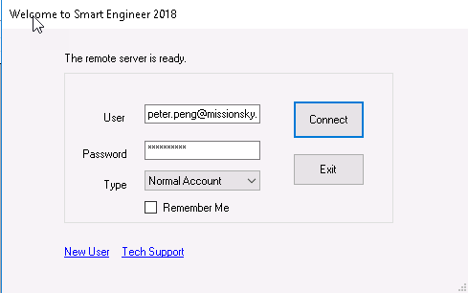

public interface IAccountService

string Login(AccountType accountType, string userName, string Password);

void Logout(string accessToken);

bool ValidateToken(string accessToken);

Account GetAccountProfile(string accessToken);

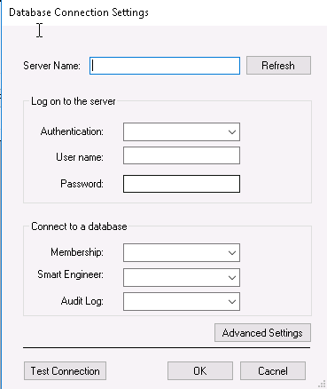

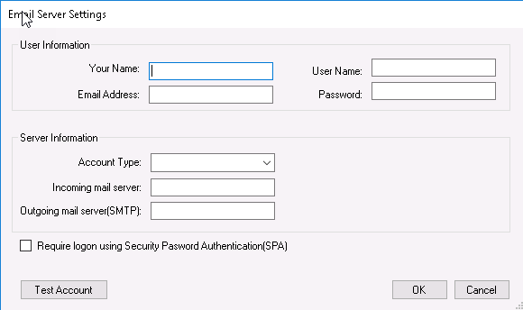

public interface ISettingService

void GetAllConfigs();

List<ConfigOption> GetConfigOptions(string configName);

void UpdateConfigOptions(List<ConfigOption> options);

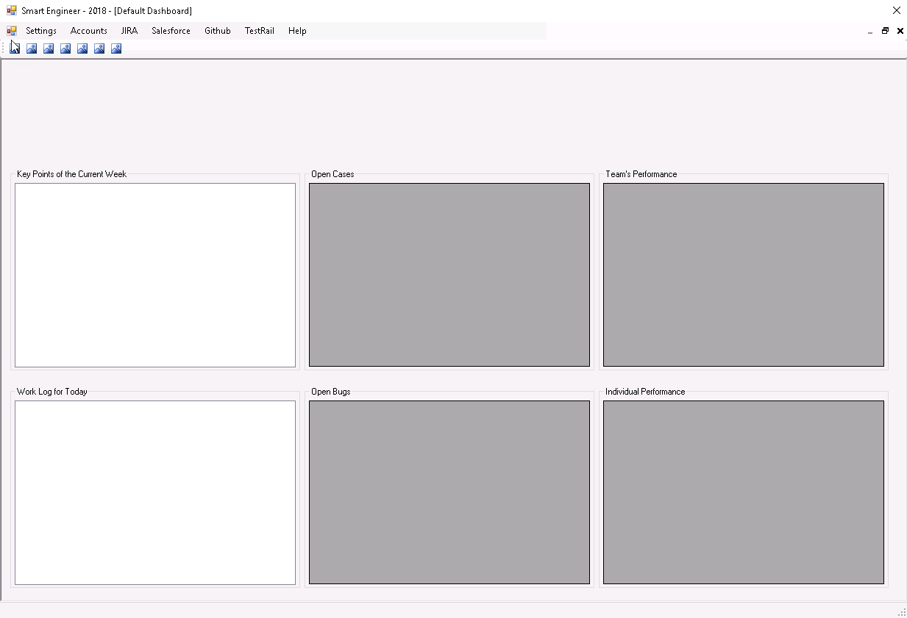

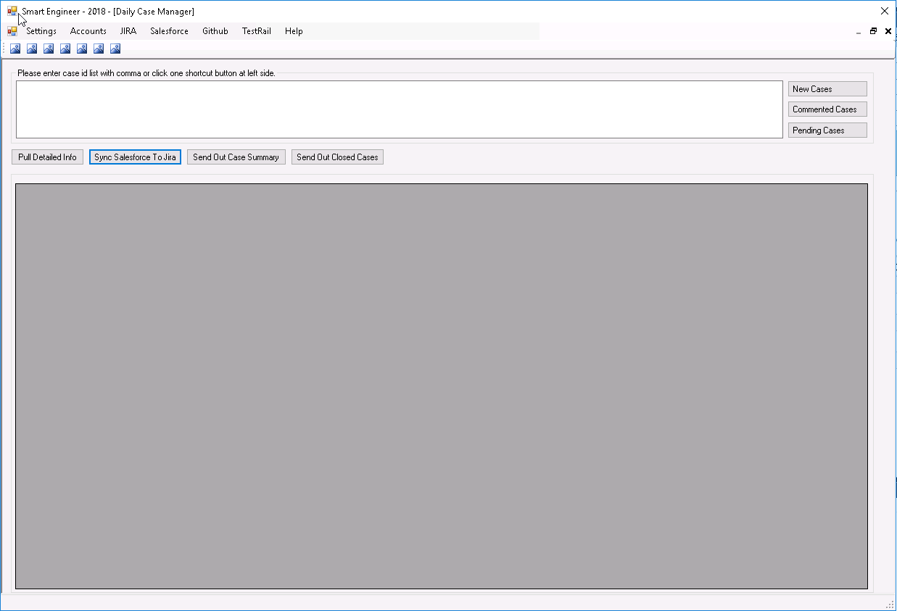

public class SalesforceService : ISalesforceService

public void GetNewCaseList()

public void GetCommentedCaseList()

public void GetIssuesBySalesforceIDList(List<string> caseIDList)

Key Point: Local First, Remote Second.

public class JiraServiceForENGSupp : IJiraServiceForENGSupp

public void GetIssuesByStatusList(List<string> statusList)

public void GetIssuesBySalesforceIDList(List<string> caseIDList)

public void SyncSalesfoceToJira(List<string> caseIDList)

include: Import new case

Update case

Sync Case Comment

Sync Status

public class ReportService : IReportService

public void SendOutClosedCaseReport(List<string> caseIDList)

public void SendOutDailyCaseReport (List<string> caseIDList)

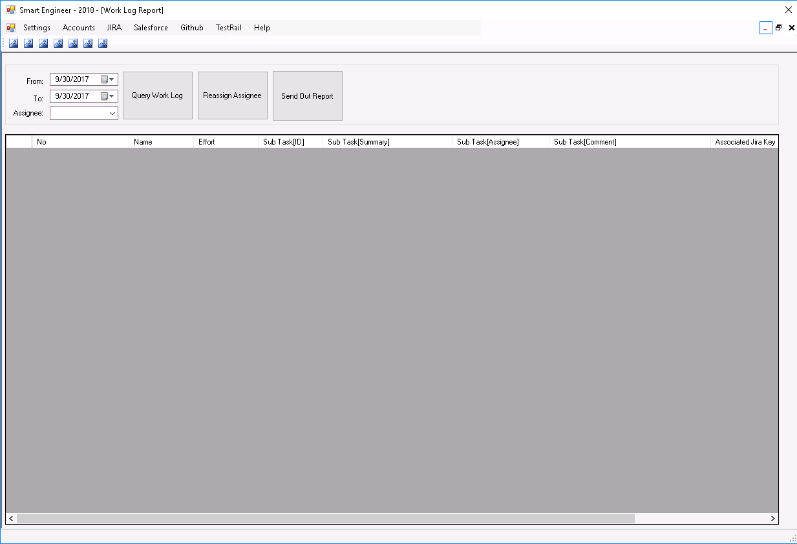

public class JiraService : IJiraService

public void GetUpdatedIssues(DateTime from, DateTime to, List<string> assignees)

public void GetWorkLogs(string jiraKey)

将上面两个合成一个方法：

public void GetWorkLogs(DateTime from, DateTime to, List<string> assignees)

public void UpdateAssignee(string jiraKey, string assignee)

public void UpdateAssigneeQA(string jiraKey, string assignee)

public class ReportService : IReportService

public void SendOutDailyWorkLogReport()

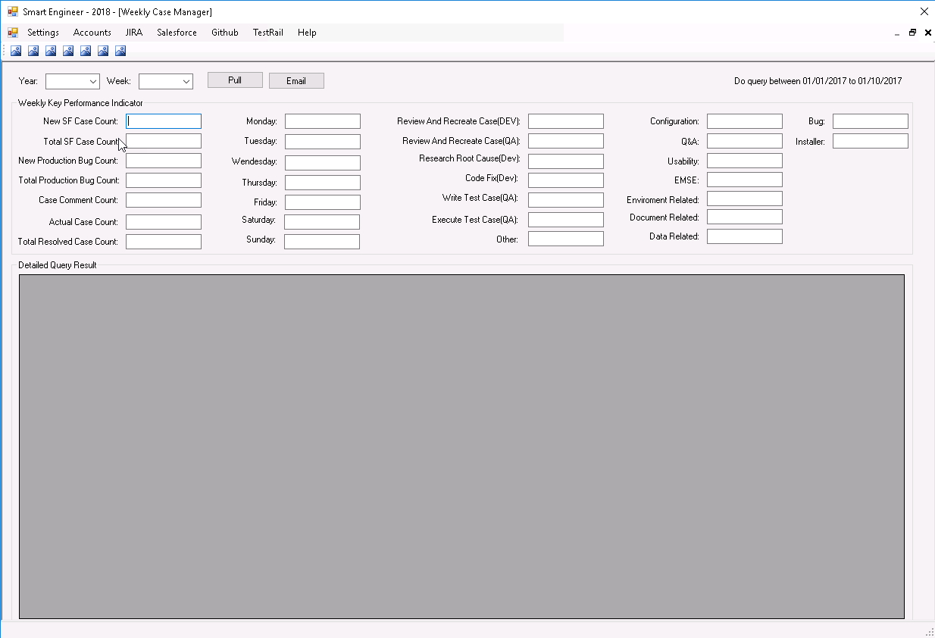

public class JiraServiceForENGSupp : IJiraServiceForENGSupp

public void GetNewIssueCount(DateTime from, DateTime to)

public void GetResolvedIssueCount(DateTime from, DateTime to)

public void GetProductionBugCount(DateTime from, DateTime to)

public void GetProductionBugCount()

public void GetTotalTimeSpent(string subTask, DateTime from, DateTime to)

public void GetTotalTimeSpent(string category, DateTime from, DateTime to)

public class SalesforceService : ISalesforceService

public void GetProcessedCase(DateTime from, DateTime to, List<string> sfAccounts)

public void GetTotalNewCaseCount()

public void GetCaseCommentCount(DateTime from, DateTime to)

public void GetReviewedCaseCount(DateTime from, DateTime to)

public void GetReviewedCaseCount(DateTime workday)

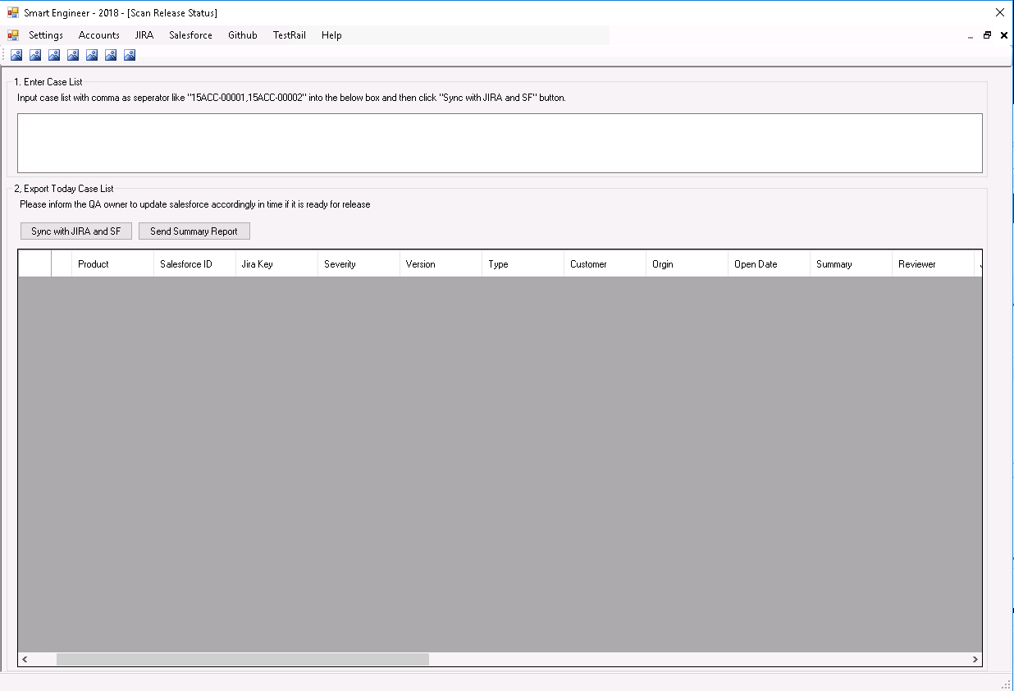

public class SalesforceService : ISalesforceService

public void GetIssuesBySalesforceIDList(List<string> caseIDList)

Key Point: Local First, Remote Second.

public class JiraServiceForENGSupp : IJiraServiceForENGSupp

public void GetIssuesBySalesforceIDList(List<string> caseIDList)

public class ReportService : IReportService

public void SendOutReleaseStatusReport(List<string> caseIDList)

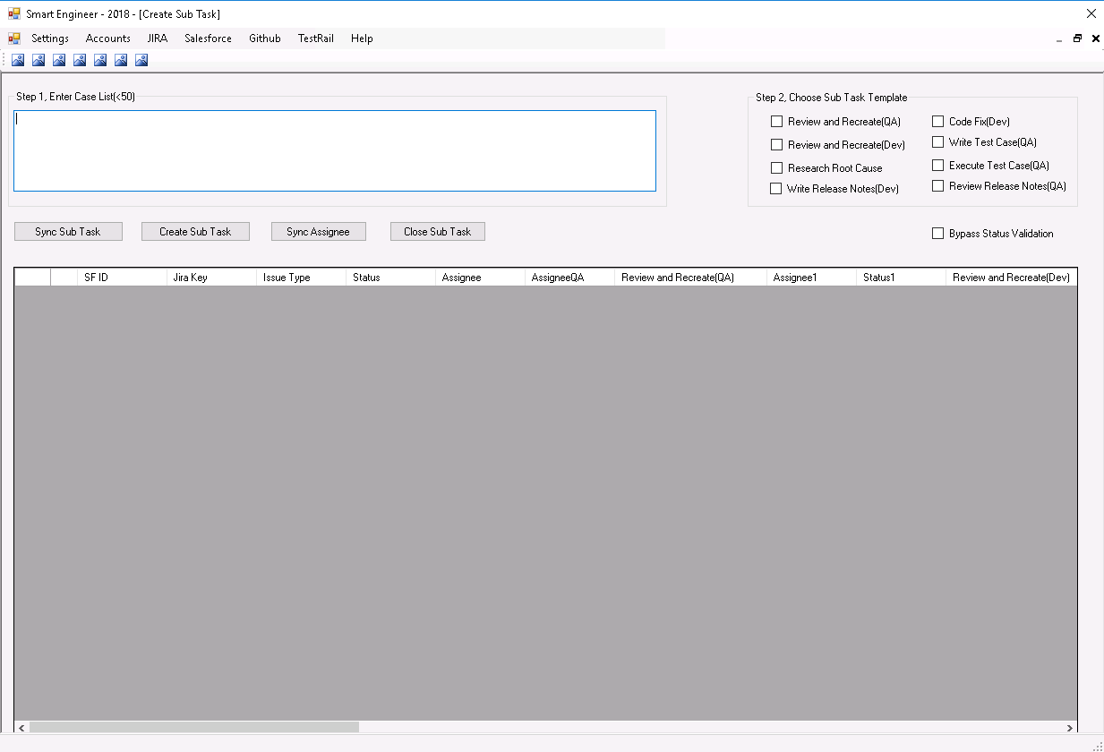

public class JiraService : IJiraService

public void GetSubTasks(string jiraKey)

public void UpdateSubTasks(string jiraKey, SubTask subTask)

public void CloseSubTasks(string jiraKey)

public void UpdateAssignee(string jiraKey, string assignee)

public void UpdateAssigneeQA(string jiraKey, string assignee)

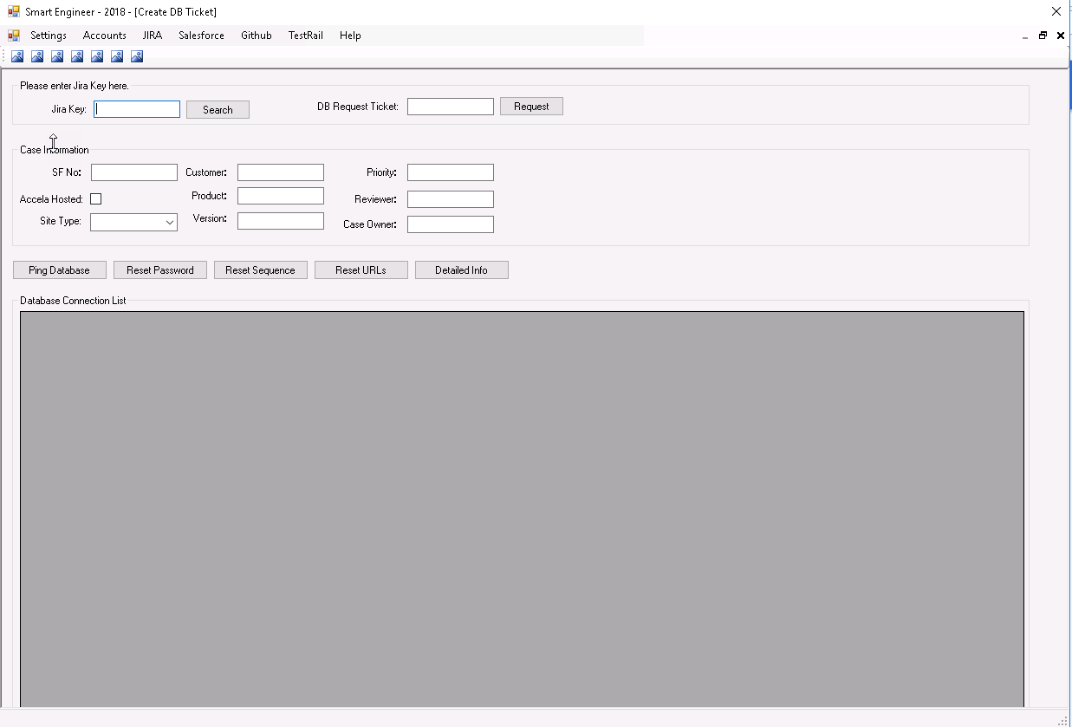

public class SalesforceService : ISalesforceService

public void GetIssuesBySalesforceIDList(List<string> caseIDList)

Key Point: Local First, Remote Second.

public class JiraServiceForENGSupp : IJiraServiceForENGSupp

public void GetIssuesBySalesforceIDList(List<string> caseIDList)

public interface IJiraServiceForDatabase

public void GetDBTicket(string sfNo)

public void SubmitDBTicket(string jiraKey, DBTicket ticket)

public interface IDatabaseManagementService

public void GetDBConnections(string customer)

public void PingDBConnection(string connectionId)

public void ResetAAPassword(string connectionId)

public void ResetAASequence(string connectionId)

public void ResetAAURLs(string connectionId)

public void GetDetailedConnectionInfo(string connectionId)

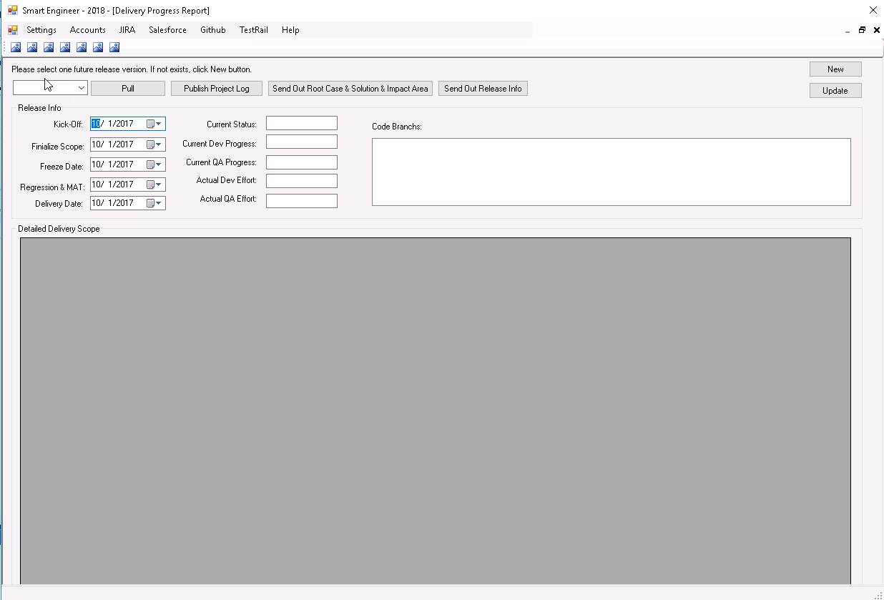

public class JiraService : IJiraService

public void GetIssuesByLabelList(List<string> labelList)

public void GetSubTasks(string jiraKey)

public void GetWorkLogs(string jiraKey)

public void GetCaseStudy(string jiraKey)

Include: Root Cause, Solution, Impact Area and Release Notes

public class ReleaseManagementService : IReleaseManagementService

public void CreateRelease(string name, DateTime kickoff, DateTime finalizeScope, DateTime freezeCode, DateTime regressionAndMAT, DateTime delivery)

public void UpdateRelease(string name, DateTime kickoff, DateTime finalizeScope, DateTime freezeCode, DateTime regressionAndMAT, DateTime delivery)

public void AddJiraFilter(string name, string url)

public void AddCodeBanch(string name, string url)

public void AddTestRail(string name, string url)

public void GetExistingScopeItems(string name, List<Issues> items)

public void SubmitNewScopeItems(string name, List<Issues> items)

public class TestRailService : ITestRailService

public class GitHubService : IGitHubService

public class ConfluenceService : IConfluenceService

public class ReportService : IReportService

public void SendOutReleaseSummaryReport(string name)